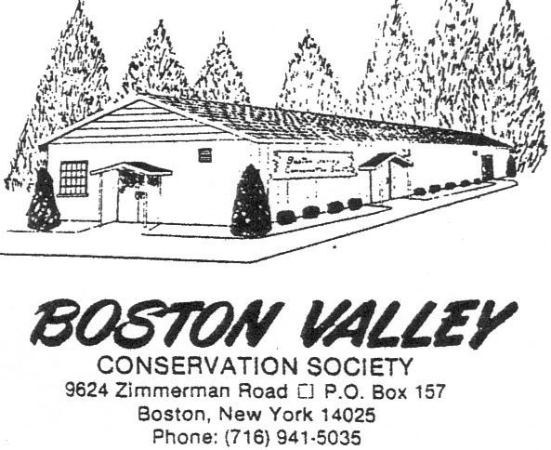
DATE: _______________
I hereby apply for membership in the BOSTON VALLEY CONSERVATION SOCIETY, INC.
Current NRA Members: $75
Non-NRA Members: $120 (includes NRA membership)
Spouse membership is $37.50
I (am) (am not) a citizen of the United States.
If elected to membership, I agree to be bound by the laws, rules and by-laws of the Society, and to obey all instructions and orders of any chairman or range officer so designated by the club membership. I understand that I will be required to serve on work parties and committees and assist at club functions and activities. I hereby affix my signature to acknowledge that I promise to fulfill my obligations to the best of my ability.
Signature of Applicant: ______________________________________________
NAME: __________________________________________________________________ AGE: ________________
ADDRESS: __________________________________________________________________________________________ (Street) (City) (State) (Zip)
PHONE: _________________________________________ YEARS RESIDENCE: __________________________
N.R.A. MEMBER: (YES) (NO) N.R.A. #: ___________________________________________
EMPLOYER: ___________________________________ EMAIL: __________________________________________
RECOMMENDED BY: __________________________________________________________________________________
CURRENT PISTOL PERMIT HOLDER: ______________________ PERMIT NUMBER: _______________________________
UNDER 18, SIGNATURE OF PARENT OR GUARDIAN: _________________________________________________________
SPOUSE MEMBERSHIP (OPTIONAL): (YES) (NO)
SPOUSE’S NAME: ____________________________________________________________________________________
RETURN APPLICATION TO: Collin Snyder, Membership Committee Chairman
By mail: Boston Valley Conservation Society, PO Box 157, Boston, NY 14025
By email: bvcsmembership@gmail.com

